Shaik Shafeeq [RA2311030010015] - AppSec Hackathon
Challenge 1 — The Broken Login
Task A – Exploit
Payload 1 (Login as Alice without password)
Username:
alice' --
Password:
anything
Successful Login:
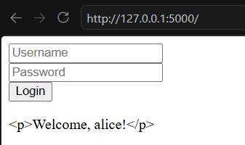
Everything after -- is ignored.

Payload 2 (Login using only password field)
Username:
anything
Password:
' OR '1'='1

Since '1'='1' is always true, login succeeds.

Task B – Fix
Replace:
query = f"SELECT * FROM users WHERE username='{u}' AND password='{p}'"
row = conn.execute(query).fetchone()
with:
row = conn.execute(
"SELECT * FROM users WHERE username=? AND password=?",
(u, p)
).fetchone()

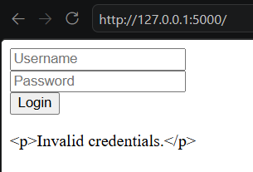

Task C
SQL injection occurs when user input is directly concatenated into a SQL query. An attacker can insert SQL syntax that changes the intended query logic. This can allow bypassing authentication, reading data, or modifying records. Parameterized queries separate SQL code from user data. The database treats user input only as values and not executable SQL commands. This prevents attackers from injecting malicious SQL statements.

Challenge 2 — The Comment Box That Bites Back
Task A – Exploit
Payload 1 (Alert)
Post comment:
<script>alert('XSS')</script>
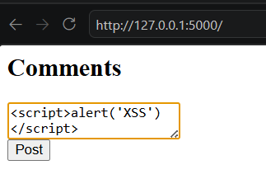
Alert appears.
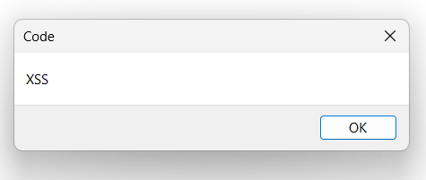

Payload 2 (Steal Cookie)
Post:
<script>alert(document.cookie)</script>
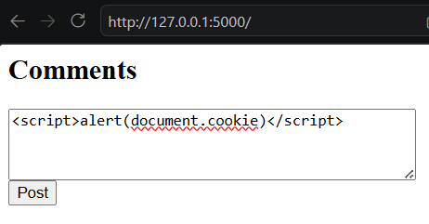
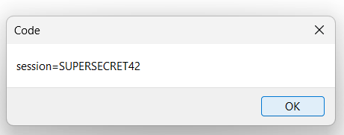
Alert appears.

Task B – Fix
Fix 1
Replace:
<div>{{ c | safe }}</div>
with:
<div>{{ c }}</div>
Now scripts appear as text.
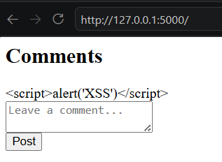

Fix 2
Replace:
resp.set_cookie('session', 'SUPERSECRET42')
with:
resp.set_cookie(
'session',
'SUPERSECRET42',
httponly=True
)
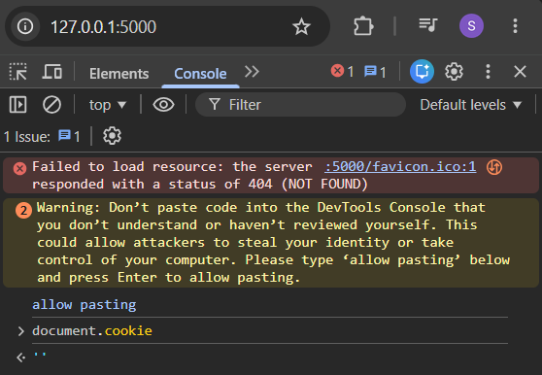

Task C
Reflected XSS occurs when malicious input is immediately returned in the server response and executed in the victim's browser. Stored XSS occurs when malicious code is permanently stored on the server and later executed when users view the content. This challenge demonstrated Stored XSS because the script was saved as a comment and executed whenever the page loaded. Stored XSS is generally more dangerous because it affects every user who views the page. Attackers can steal sessions, perform actions on behalf of users, or distribute malware.

Challenge 3 — The Invoice Peek

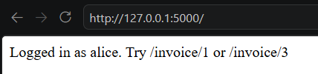
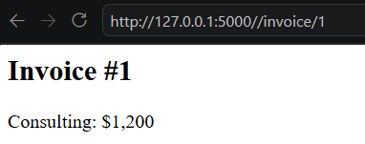
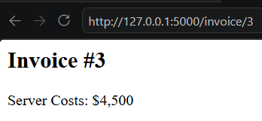

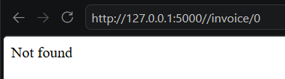
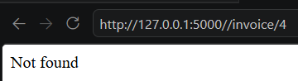
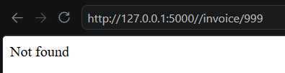

This reveals invoice existence through different responses.

Task B – Fix
Replace:
if not inv:
return 'Not found', 404
with:
if not inv:
return 'Not found', 404
if inv['owner'] != session['user']:
return 'Access denied', 403

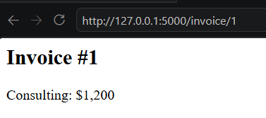
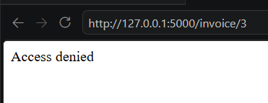

Task C
Authentication verifies who a user is, while authorization determines what resources that user can access. In this challenge, Alice was successfully authenticated because the application knew she was logged in. However, the application did not verify whether Alice owned the requested invoice. As a result, Alice could access Bob's invoice by changing the URL. This is an Insecure Direct Object Reference (IDOR) vulnerability caused by missing authorization checks.

Challenge 4 — Three Locks, All Broken
Task A:
Flaw 1
Vulnerable line:
app.secret_key = 'abc'
Issue:
Weak secret key.
Attack:
Attackers can forge Flask session cookies.

Flaw 2
Vulnerable line:
hashlib.md5(...)
Issue:
MD5 password hashing.
Attack:
Passwords can be cracked quickly using rainbow tables or brute force.

Flaw 3
Vulnerable line:
session.pop('user', None)
Issue:
Only removes one session value.
Attack:
Other session data may remain active.

Task B
Fix Code
Secure Secret Key
import secrets
app.secret_key = secrets.token_hex(32)

Password Hashing
Add:
from werkzeug.security import generate_password_hash
from werkzeug.security import check_password_hash
Users:
USERS = {
'admin': generate_password_hash('admin123'),
'alice': generate_password_hash('alicepass')
}
Login check:
if u in USERS and check_password_hash(USERS[u], p):
session['user'] = u
return redirect('/dashboard')
Logout Fix
Replace:
session.pop('user', None)
with:
session.clear()

Task C
MD5 is considered insecure because it is extremely fast and vulnerable to brute-force and rainbow-table attacks. It also lacks built-in salting, making identical passwords produce identical hashes. Bcrypt and Argon2 are intentionally slow password hashing algorithms designed to resist large-scale cracking attempts. They automatically use salts and allow configurable cost factors that increase the computational effort required for each password guess. This makes password cracking significantly more difficult.
Challenge 5 – Security Headers
Task A
Visit
http://127.0.0.1:5000/error
Debug mode exposes:
Stack trace
Source code
Environment information
Sensitive configuration details
Danger:
Attackers gain information useful for further attacks.
Missing Security Headers
X-Frame-Options
X-Content-Type-Options
Content-Security-Policy
Referrer-Policy
HTML Security Issue
<iframe src="https://evil.com"></iframe>
External untrusted content.
Curl
curl -I http://localhost:5000/
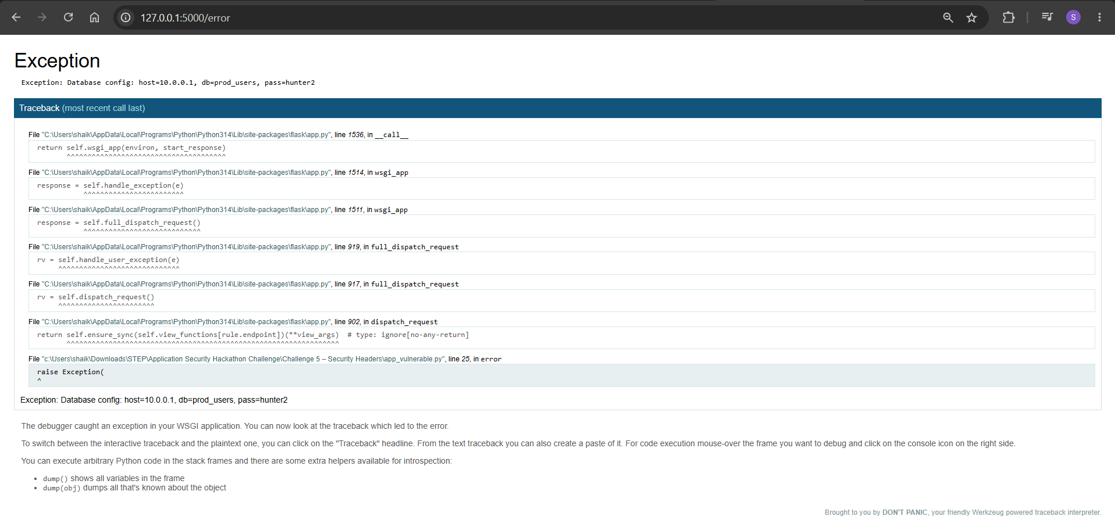
Task B Fix
Disable Debug
app.config['DEBUG'] = False

Add Headers
@app.after_request
def add_security_headers(response):
response.headers['X-Frame-Options'] = 'DENY'
response.headers['X-Content-Type-Options'] = 'nosniff'
response.headers['Content-Security-Policy'] = "default-src 'self'"
response.headers['Referrer-Policy'] = 'strict-origin-when-cross-origin'
return response

Remove iframe
Replace:
<body>
<h1>Hello, world!</h1>
<iframe src="https://evil.com"></iframe>
</body>
with:
<body>
<h1>Hello, world!</h1>
</body>
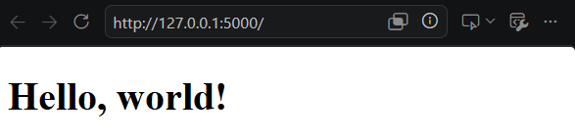
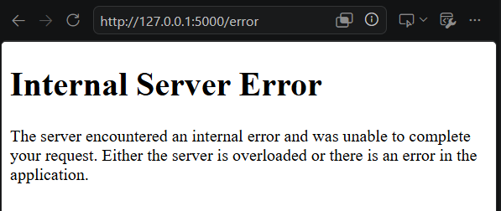

Task C
X-Frame-Options
X-Frame-Options prevents clickjacking attacks by stopping a page from being embedded inside a frame. Without this header, an attacker can place the application inside an invisible iframe and trick users into clicking hidden buttons. This could result in unauthorized actions being performed on behalf of the victim.
Content-Security-Policy
Content-Security-Policy restricts the sources from which scripts, styles, and other resources can be loaded. Without CSP, attackers may inject malicious JavaScript through XSS vulnerabilities. This can lead to session theft, account compromise, or data exfiltration.

Bonus:
# .github/workflows/pipeline.yml

name: AppSec Scan

on:
push:
pull_request:

jobs:
security-scan:
runs-on: ubuntu-latest

steps:
- uses: actions/checkout@v4

- name: Setup Python
uses: actions/setup-python@v5
with:
python-version: "3.11"

- name: Install Tools
run: |
pip install bandit safety semgrep

- name: Run Bandit
run: |
bandit -r challenge1
bandit -r challenge2
bandit -r challenge3
bandit -r challenge4
bandit -r challenge5

- name: Run Semgrep
run: |
semgrep --config=auto .

- name: Run Safety
run: |
safety scan

